DAY 7

EMPLOYEE ID 111594594

SAIKUMAR PENTAKOTA

TASK 1

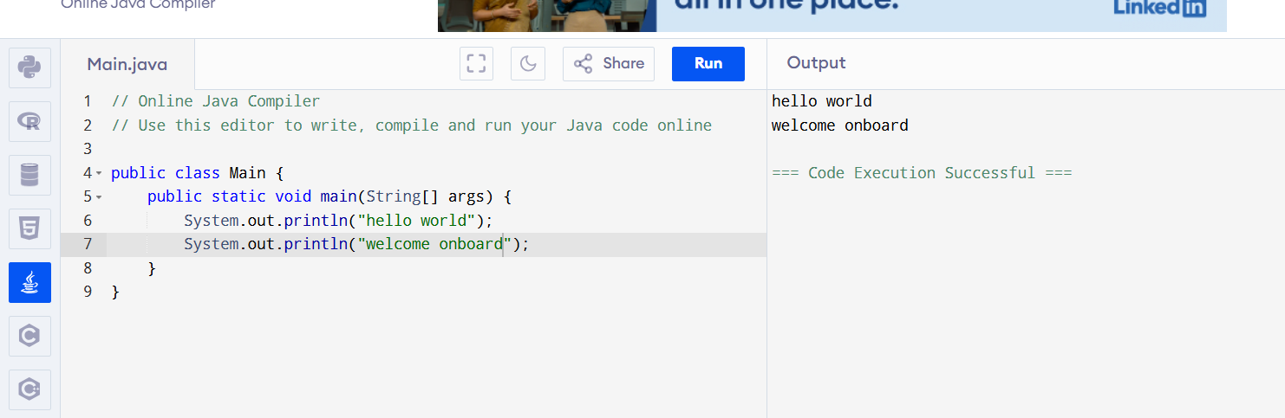

TASK 2

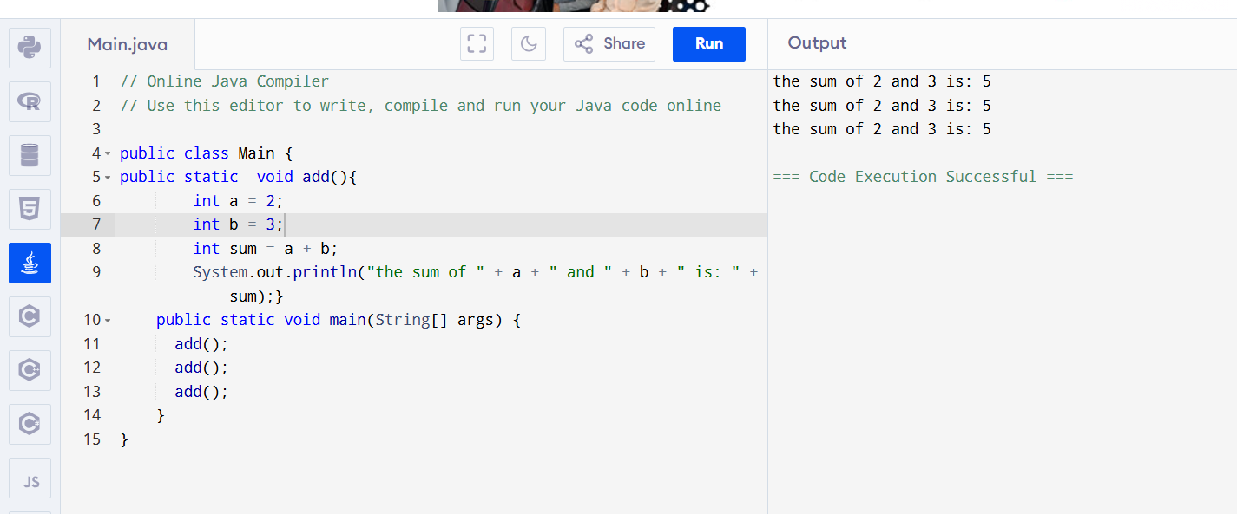

Task 3

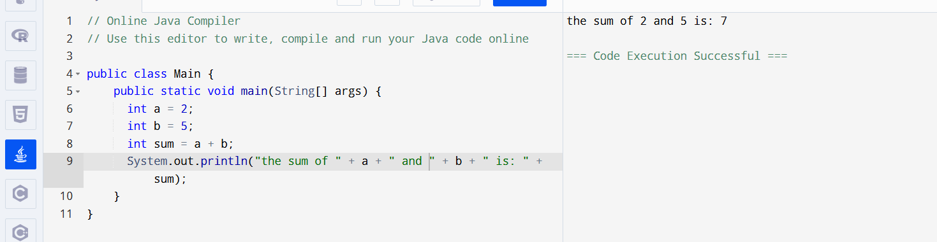

TASK 4

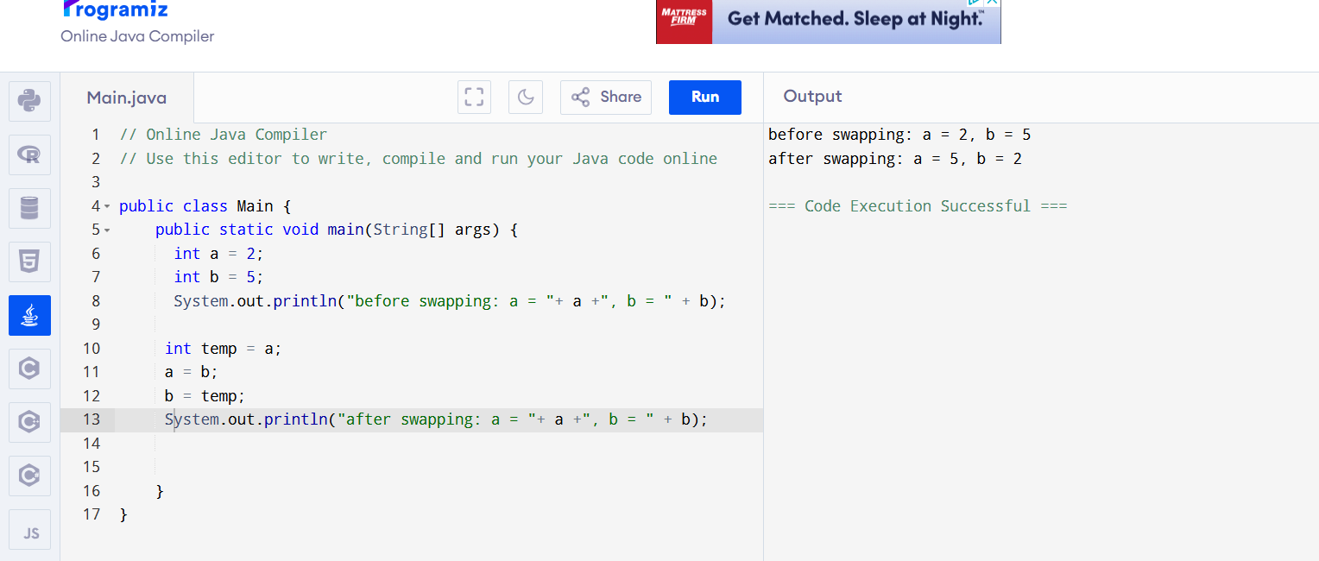

Task 6 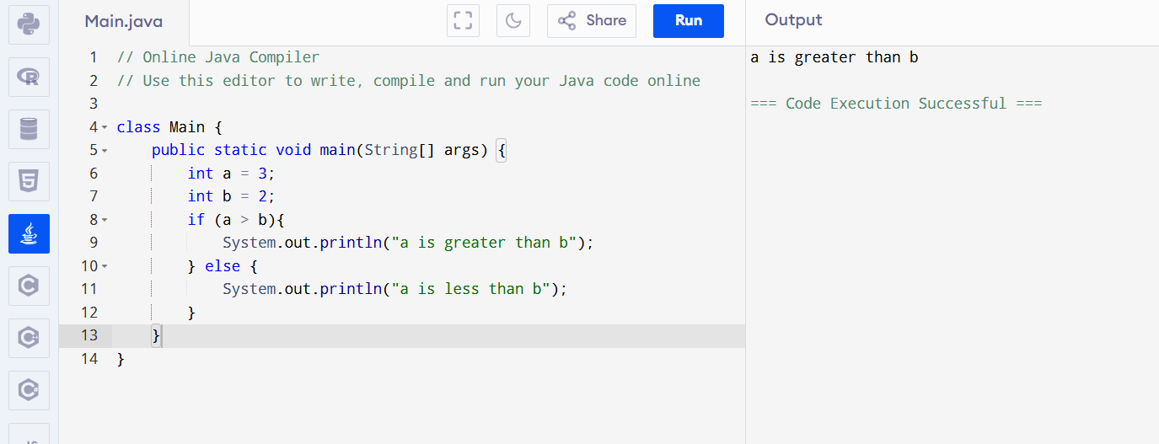

TASK 7

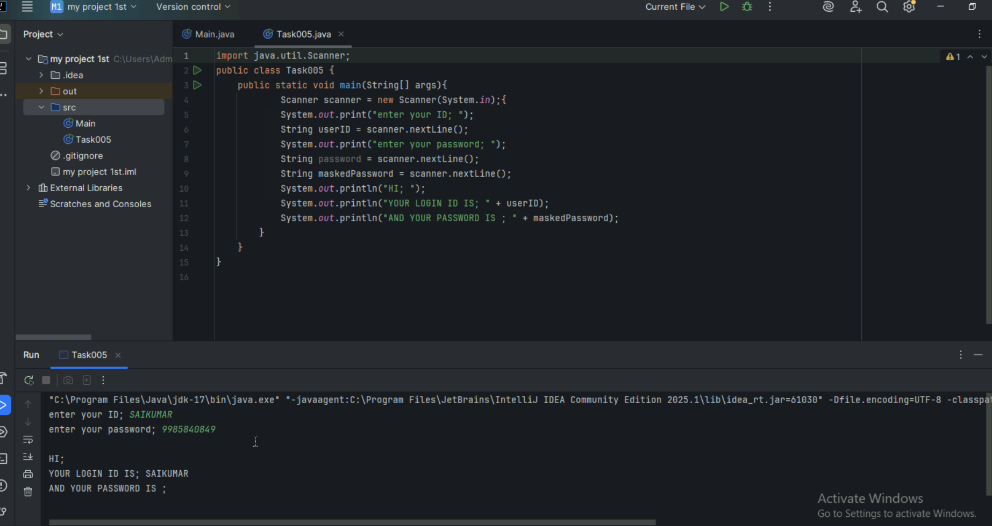

TASK 8

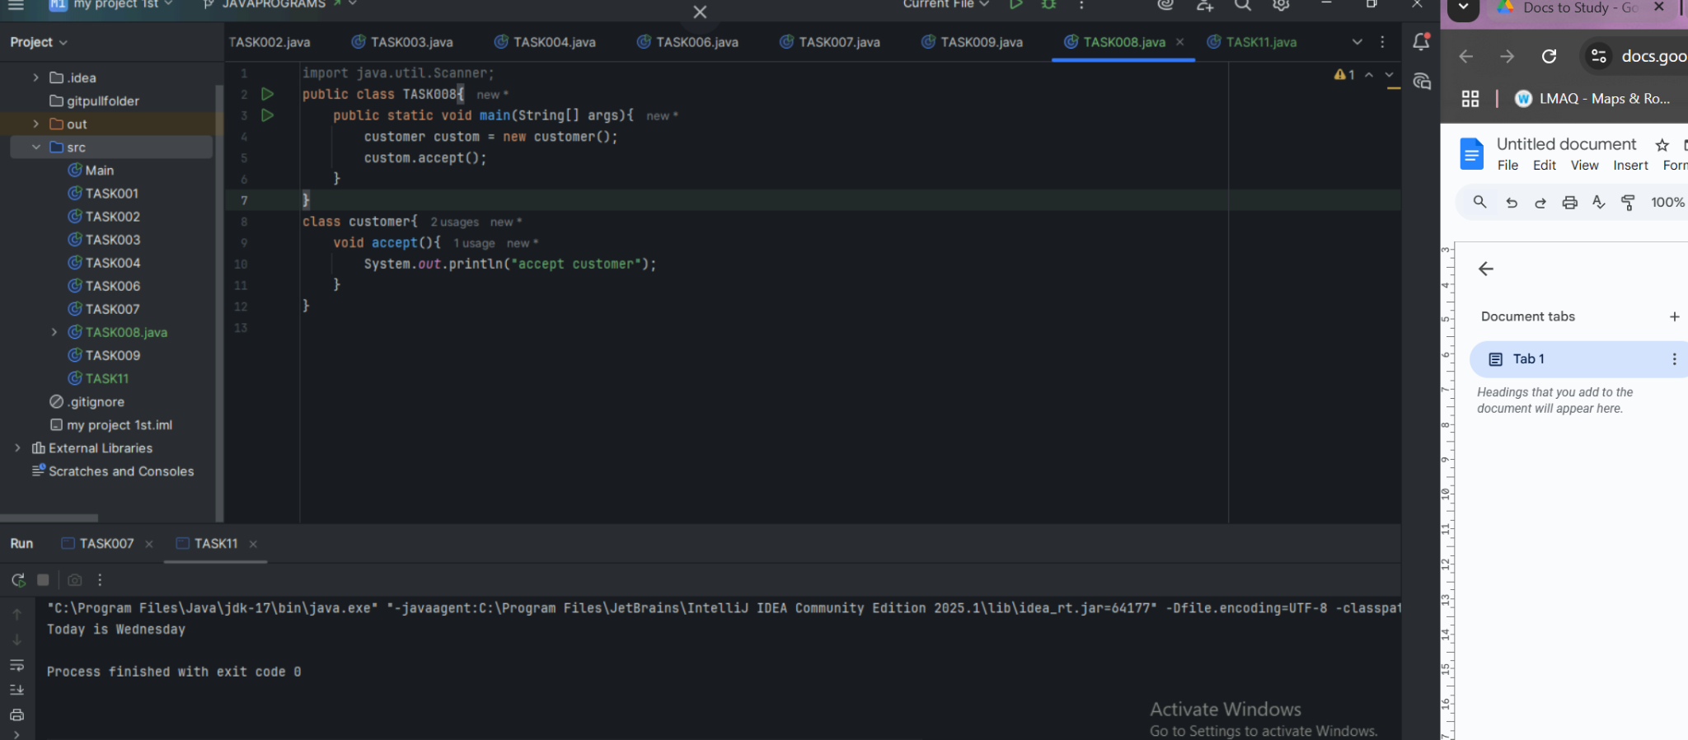

TASK 9 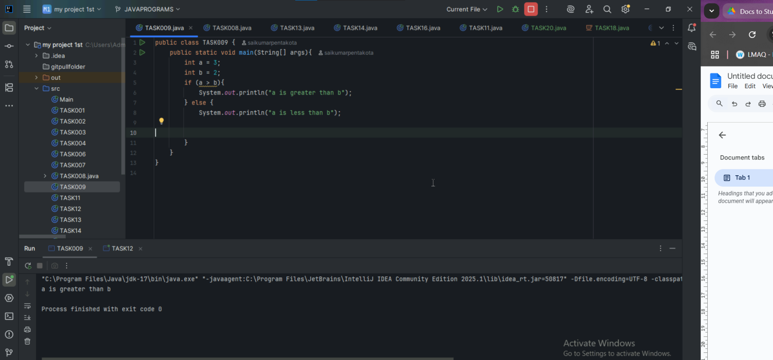

Task 10

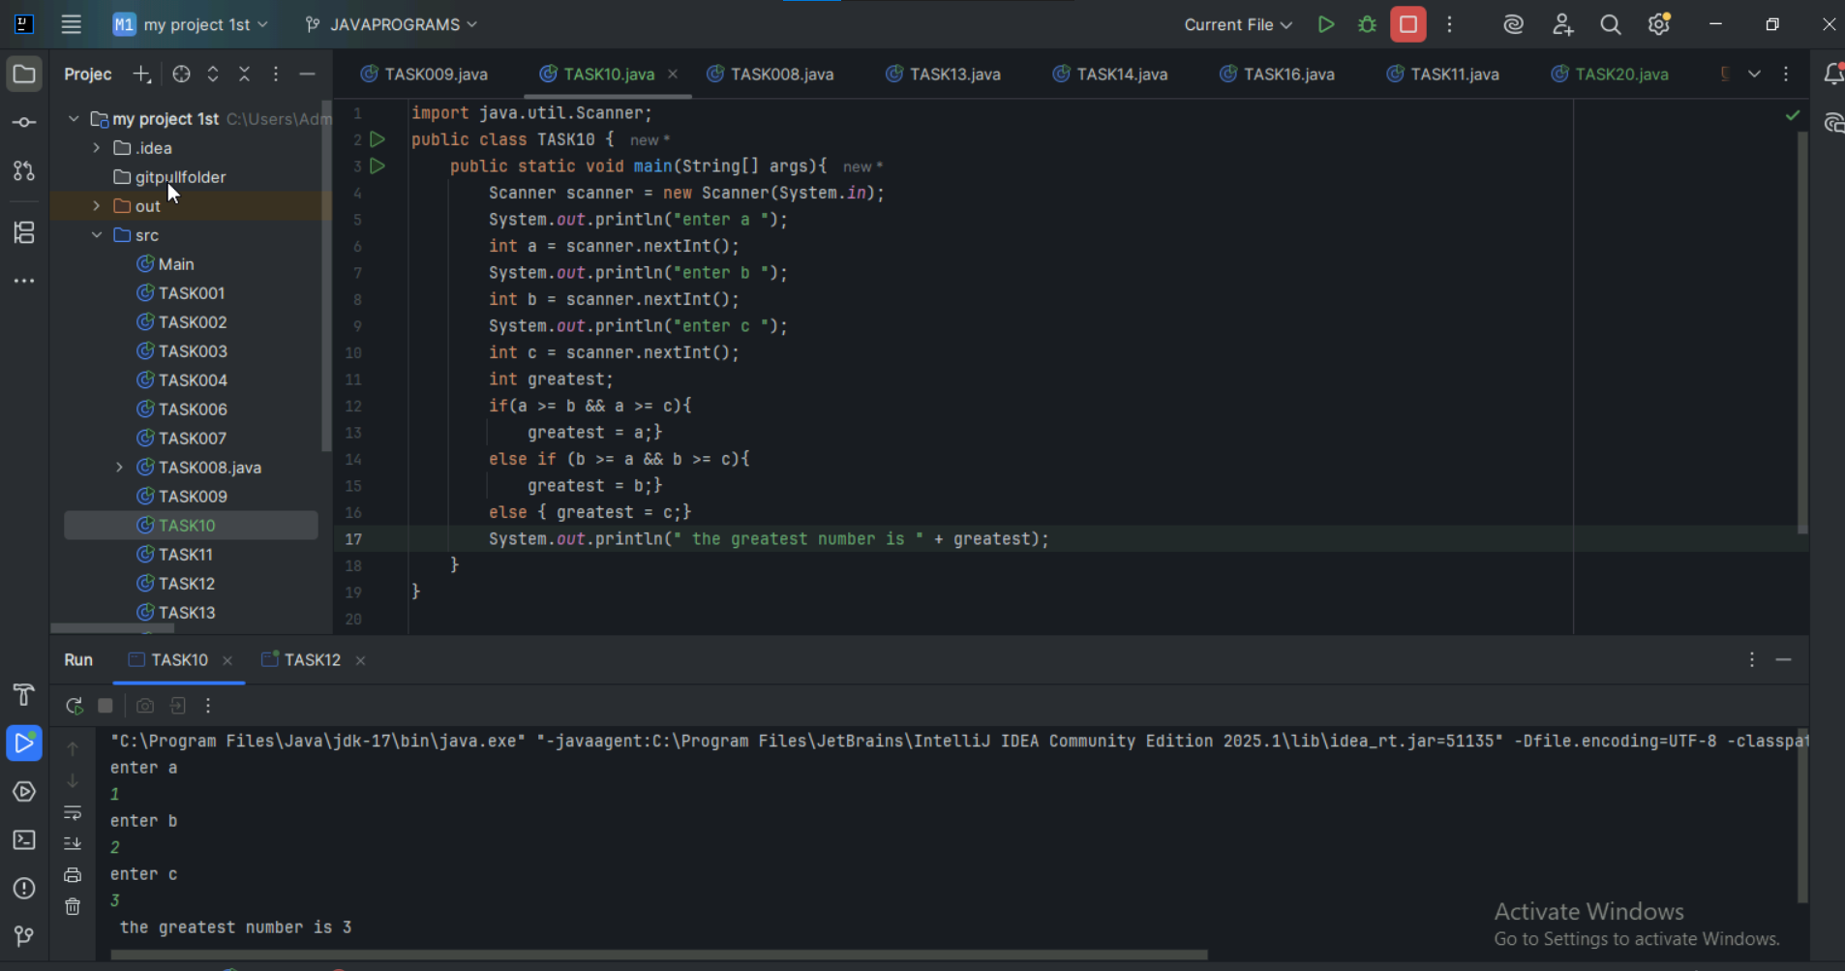

TASK 11

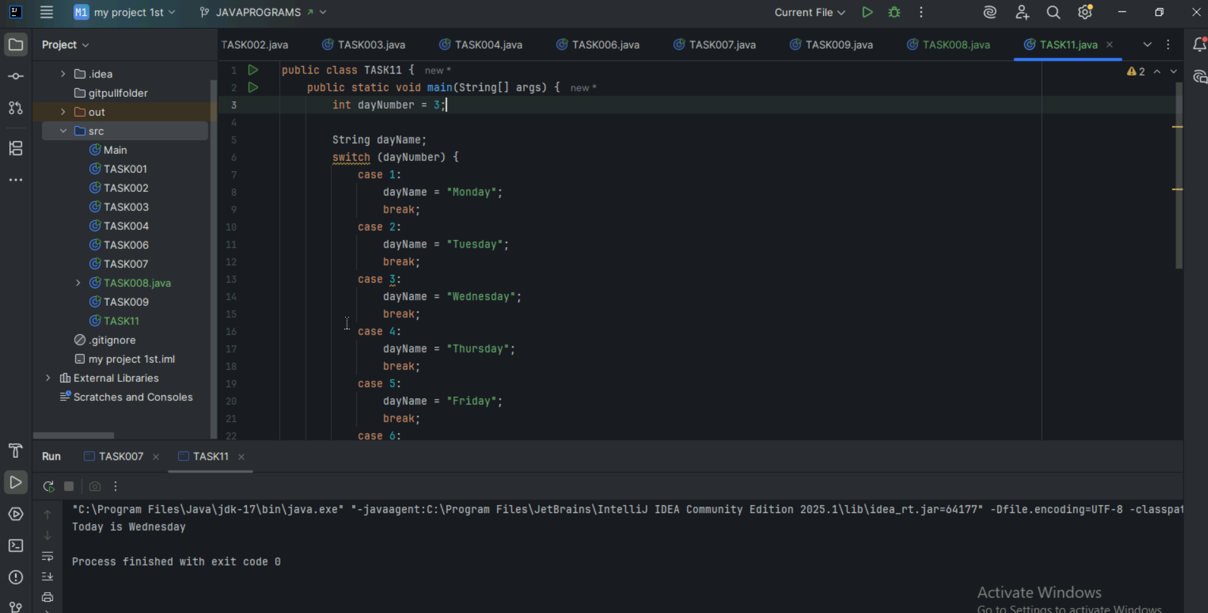

Task 12

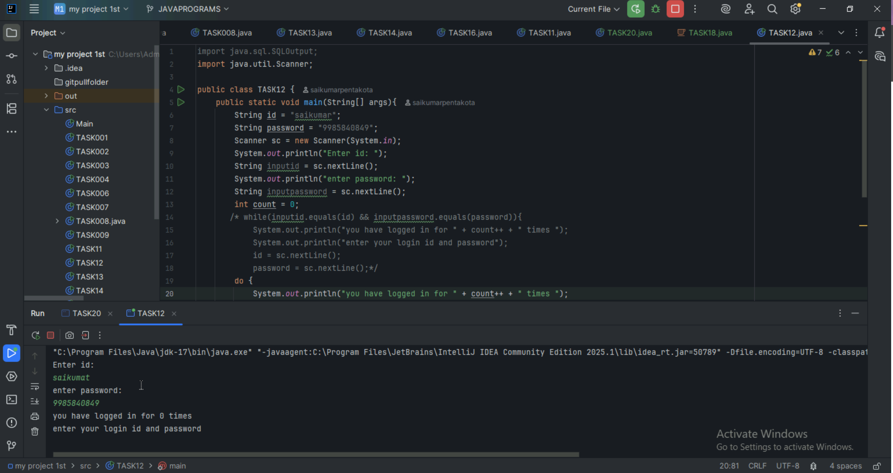

Task 13

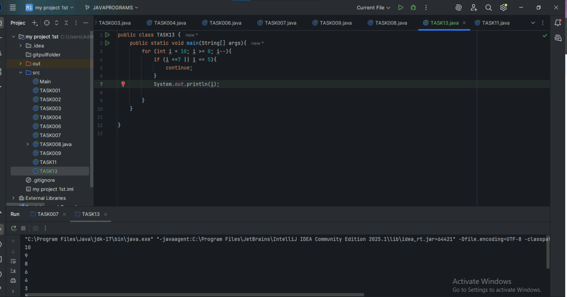

Task 14

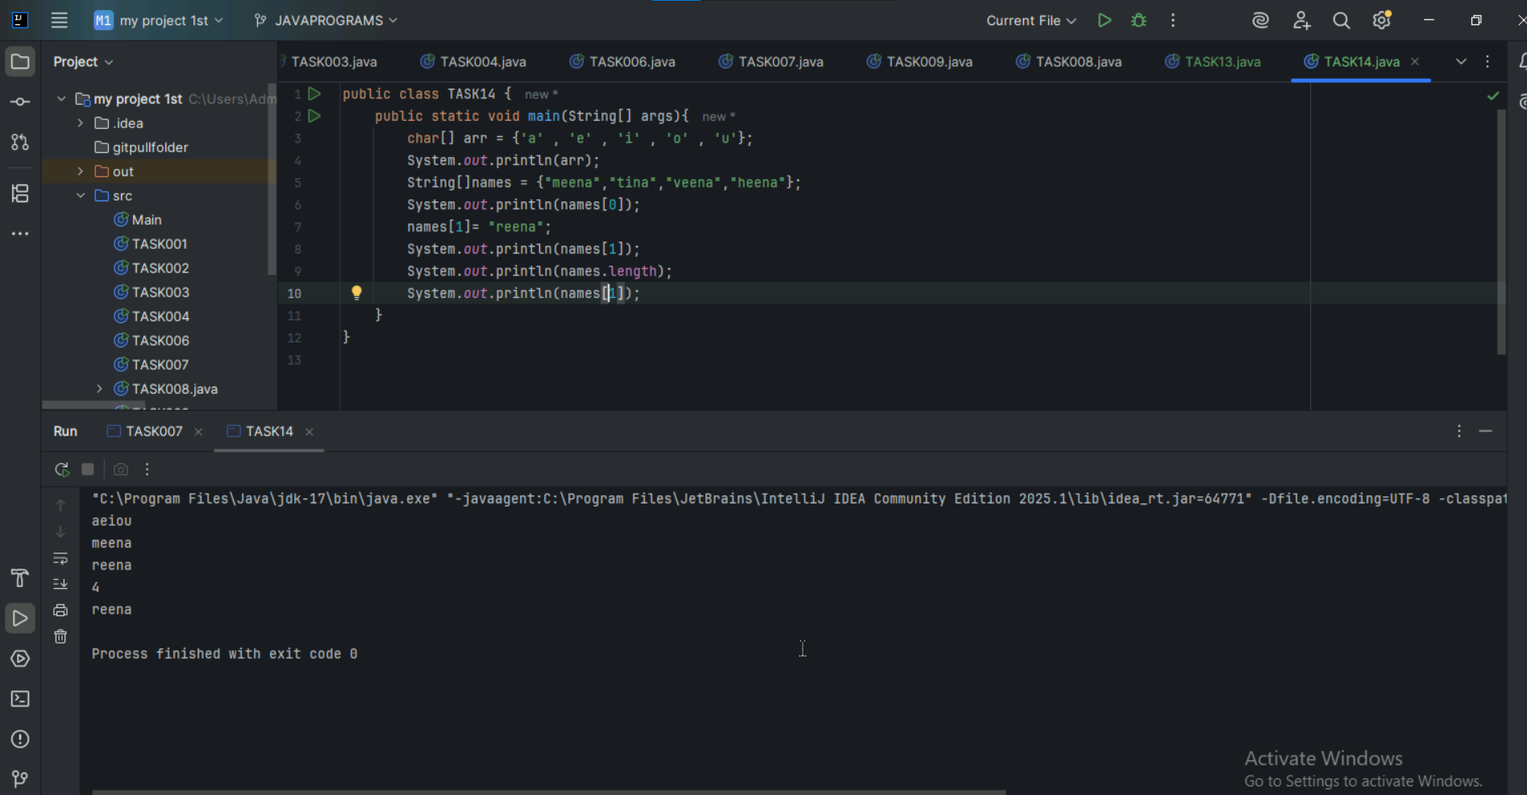

Task 16

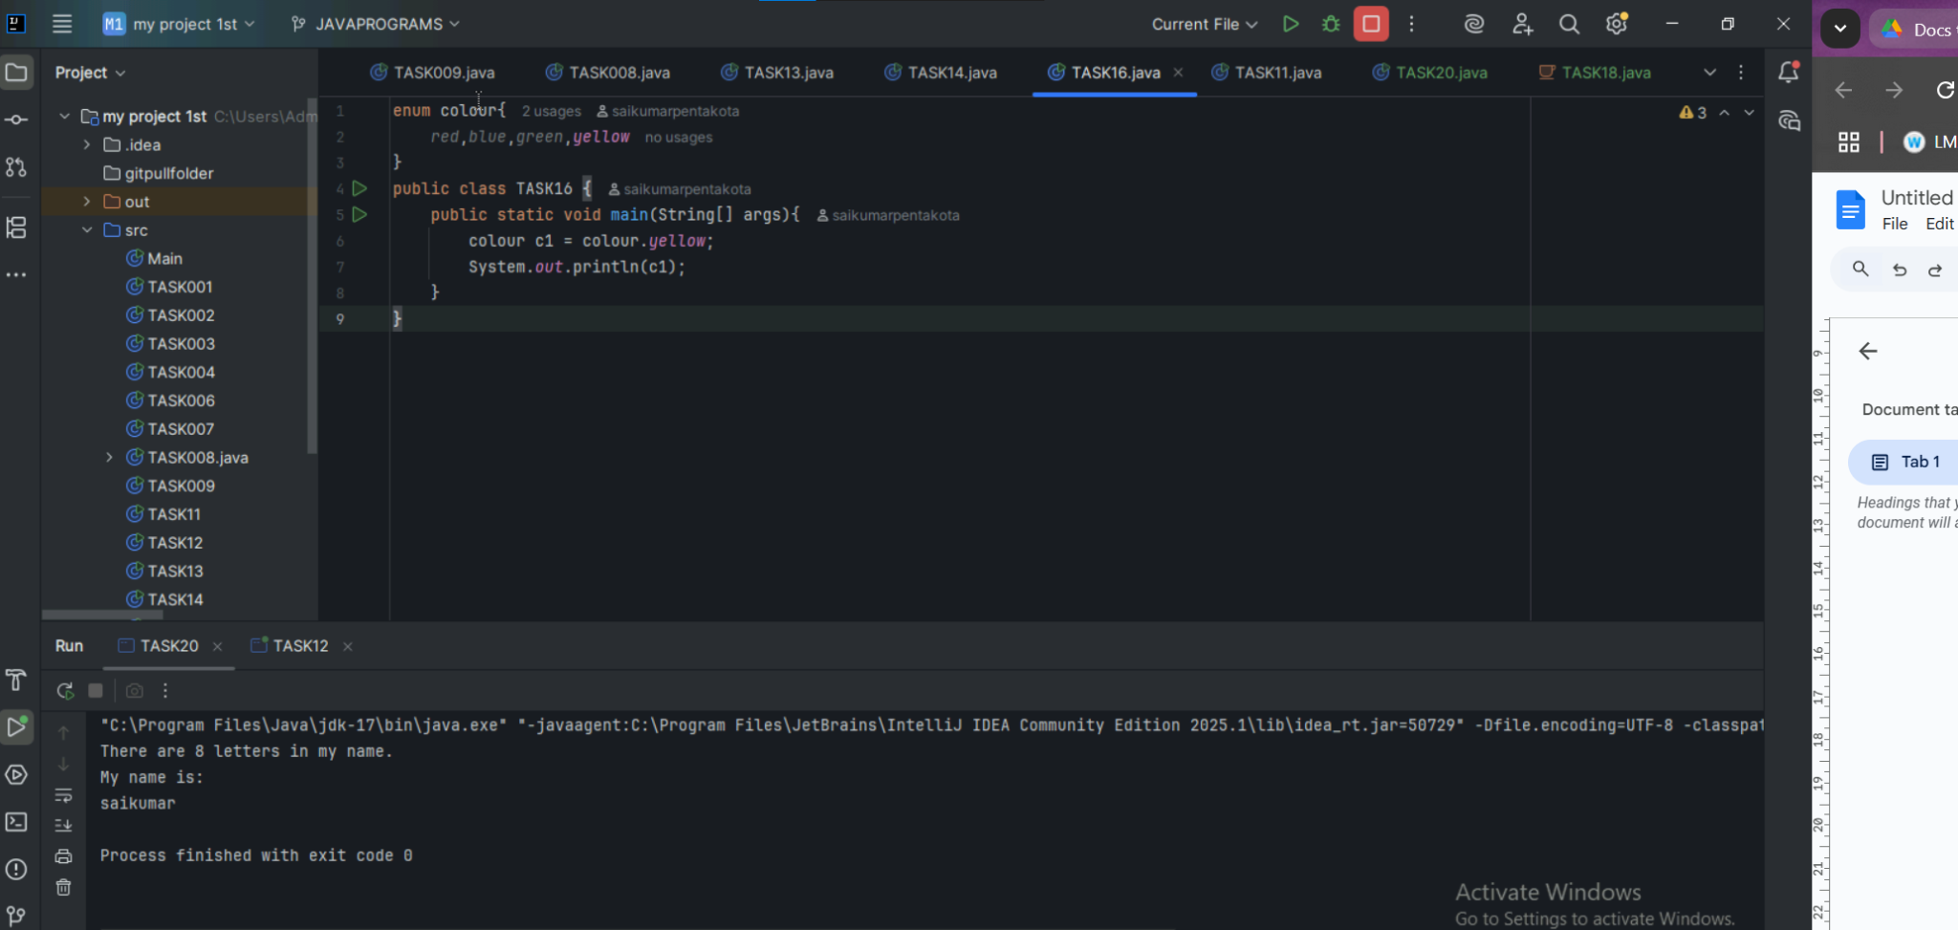

Task 20

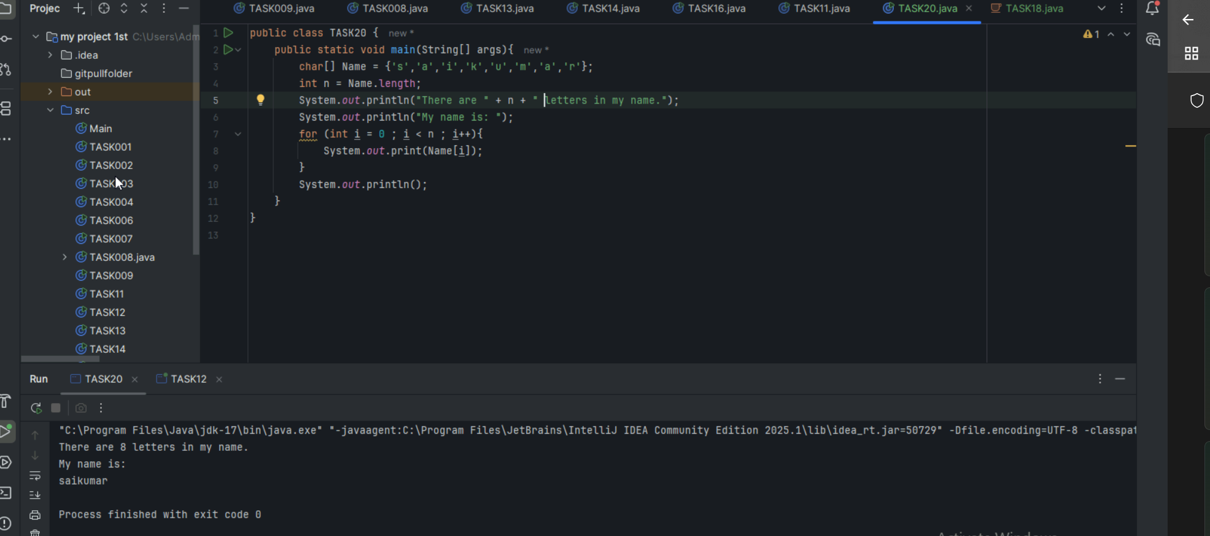

import java.io.\*;

class Myclass

{

public static void main(String[] args)

{

TestClass t = new TestClass();

t.display();

System.out.println(t.tax);

}

}

// Interface Declared

//Driver Code Ends

interface testInterface {

// public, static and final

final int tax = 10;

// public and abstract

void display();

}

// Class implementing interface

class TestClass implements testInterface {

// Implementing the capabilities of

// Interface

public void display(){

System.out.println("Myclass");

}

}